VIDHYA.R

192572153

SIMATS ENGINEERING

ASSESSMENT TOOL 5

COURSE NAME: Artificial Intelligence COURSE CODE: CSA1715

COURSE OUTCOME COVERED

CO2: Experiment search and game-solving techniques such as Greedy Search, A*, CSP, Minimax, and Alpha-Beta pruning with heuristic functions for solving complex AI problems efficiently. (BL3)

Assessment Tool Weightage: 40%

Duration: 1 Hour
QUESTIONS: 3 Total Marks:30

Annexure A

Application Based Questions

Code of Conduct:

I VIDHYA.R (192572153) certify that this submission is my original work and that I have adhered to the guidelines specified for this assessment.
I understand that any violation of academic integrity rules will result in disciplinary action.

Signature of the student:

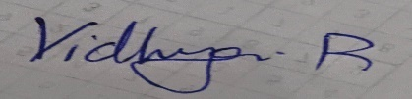
Annexure A

Application Based Questions
- Intelligent Route Planning using A* and Greedy Search.
A smart delivery system is designed to transport medical supplies between cities. The system uses informed search strategies to determine optimal routes.
The road network is given below:
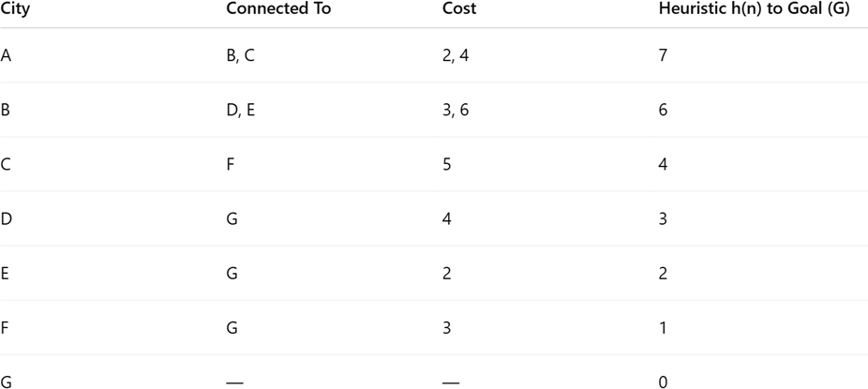

Tasks:
  - Construct the search tree from A to G.
  - Apply Greedy Best-First Search and show node expansion order.
  - Apply A* algorithm using 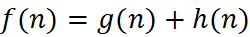 .
  - Justify which algorithm is better for real-time emergency delivery systems.

Constraint Satisfaction Problem – University Timetable Scheduling
A university must schedule final exams for 5 subjects: AI, ML, DBMS, OS, CN across 3 days (Day 1, Day 2, Day 3) with the conditions, AI and ML cannot be scheduled on the same day, DBMS must be scheduled before OS, CN cannot be on Day 1, At most 2 exams per day, A student is enrolled in AI, DBMS, and CN → these cannot overlap

Tasks:
  - Formulate this problem as a Constraint Satisfaction Problem (CSP) by defining,
Variables, Domains and Constraints
  - Draw the constraint graph.
  - Solve using Backtracking Search.
  - Apply Forward Checking or Arc Consistency and explain how it reduces the search space.

  - Provide one valid timetable solution.

Game Playing – Minimax and Alpha-Beta Pruning
An AI agent is designed to play a turn-based strategy game. The game tree is given below:
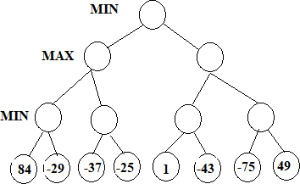

Tasks:
  - Apply the Minimax algorithm and compute values for all internal nodes.
  - Identify the optimal move for MAX.
  - Apply Alpha-Beta Pruning to Show α and β values at each step and Clearly indicate which nodes are pruned
  - Compare nodes evaluated in Minimax vs Alpha-Beta
  - Explain the importance of evaluation functions in complex games like chess.

RUBRICS FOR CALCULATION

Criteria | Weightage | Level 4 – Exemplary | Level 3 – Proficient | Level 2 – Developing | Level 1 – Beginning
Understanding of Problem  Context | 20 | Clearly understand s the  problem and  accurately identifies all requiremen ts | Good  understandin g with minor gaps | Basic  understanding; some  requirements unclear | Poor understandi ng or  misinterpret ation of the problem
Application of Concepts | 30 | Accurately applies  appropriate concepts to solve  complex problems | Applies relevant concepts  correctly with minor errors | Applies basic concepts with  limited accuracy | Fails to apply appropriate concepts
Problem-Solvi ng Approach | 20 | Logical, well-structu red, and  efficient approach | Mostly logical approach with minor gaps | Basic approach with some  inconsistencies | Illogical or unclear  approach
Accuracy of Solution | 20 | Completely correct  solution with proper justification | Mostly correct with minor  errors | Partially correct solution | Incorrect or incomplete solution
Clarity | 10 | Clear,  well-organi zed, and  properly explained solution | Understandab le with minor clarity issues | Limited clarity and explanation | Poorly presented  and difficult to understand
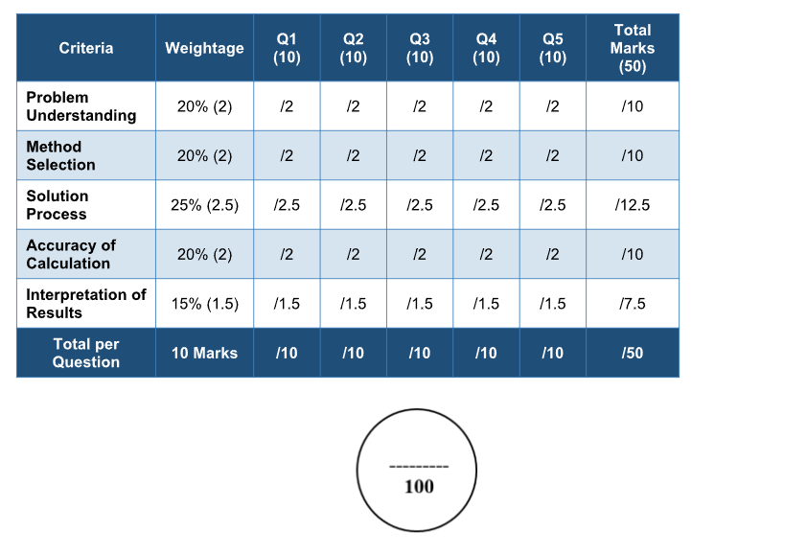

ANSWERS:

Question 1: Intelligent Route Planning using A* and Greedy Search (10 Marks)
The question is based on Informed Search Algorithms. These algorithms use heuristic information to reach the goal efficiently.

(i) Construct the Search Tree from A to G
Note:
The search tree cannot be constructed because the road network diagram is missing from the uploaded PDF.
Normally, you should:
- Start from node A.
- Expand all neighboring cities.
- Continue expanding until reaching node G.
- Represent the exploration in tree form.
Example format:
A
/ | \
B C D
/ \ \
E F G
The actual tree depends on the missing diagram.

(ii) Apply Greedy Best-First Search
Definition
Greedy Best-First Search selects the node with the lowest heuristic value h(n).
Formula:
$$f\left(n\right)=h\left(n\right)$$
It ignores the distance already travelled.
Working
- Start at A.
- Calculate heuristic values.
- Expand the node closest to the goal.
- Continue until G is reached.
Example
Suppose
Node | h(n)
A | 10
B | 7
C | 5
D | 8
G | 0
Expansion order:
A → C → G
The actual order depends on the missing road network.

(iii) Apply A* Algorithm
Formula
$$f\left(n\right)=g\left(n\right)+h\left(n\right)$$
Where
- g(n)=cost from start node
- h(n)=estimated cost to goal

Steps
- Start at A.
- Compute
f(A)=0+h(A)
- Expand node with lowest f(n).
- Repeat until G.
Example
Node | g | h | f
A | 0 | 10 | 10
B | 3 | 7 | 10
C | 4 | 5 | 9
Expand
A → C → G
Actual calculations require the missing graph.

(iv) Which Algorithm is Better?
Greedy Search
Advantages
- Very fast
- Uses only heuristic
- Less memory
Disadvantages
- May produce non-optimal path
- Can get trapped in local optimum

A*
Advantages
- Finds optimal path
- Considers both travelled cost and estimated cost
- Complete algorithm
Disadvantages
- Uses more memory
- Slightly slower

Conclusion
For emergency medical delivery,
A* is better because:
- Finds the shortest route
- Avoids unnecessary travel
- Guarantees optimal solution (with admissible heuristic)
Although Greedy Search is faster, it may miss the best path.

Question 2: Constraint Satisfaction Problem (CSP)
The university must schedule exams for:
- AI
- ML
- DBMS
- OS
- CN
Across
- Day 1
- Day 2
- Day 3
Subject to the given constraints.

(i) Formulate as CSP
Variables
X = {AI, ML, DBMS, OS, CN}

Domains
Each subject can be assigned
{Day1, Day2, Day3}

Constraints
Constraint 1
AI ≠ ML
They cannot be on the same day.

Constraint 2
DBMS before OS
Meaning
Day(DBMS) < Day(OS)

Constraint 3
CN ≠ Day1

Constraint 4
Maximum two exams each day

Constraint 5
Student studies
- AI
- DBMS
- CN
Hence
AI ≠ DBMS

DBMS ≠ CN

AI ≠ CN

(ii) Constraint Graph
AI
/ \
ML DBMS
|
|
OS
|
|
CN
Also
AI - CN
because AI and CN cannot overlap.

(iii) Solve using Backtracking
Start
AI = Day1

Next
ML ≠ Day1

ML = Day2

Next
DBMS ≠ Day1

Choose Day2
Conflict?
Student has AI and DBMS.
Cannot.
Choose
DBMS = Day3

OS
Must be after DBMS.
Impossible.
Backtrack.

Try
AI = Day2
Continue again.
Eventually obtain
Subject | Day
AI | Day1
ML | Day2
DBMS | Day2
OS | Day3
CN | Day3
Check
AI ≠ ML
DBMS before OS
CN not Day1
Maximum 2 exams/day
Student conflicts avoided

(iv) Forward Checking
Forward Checking removes values that violate constraints immediately.
Example
Suppose
AI = Day1
Then
ML cannot be Day1.
Remove Day1 from ML.
Now
ML = {Day2, Day3}
Similarly,
If
DBMS = Day2
Then
OS = Day3
Day1 and Day2 removed.
Advantages
- Reduces search space
- Avoids unnecessary backtracking
- Faster solution

Arc Consistency
Arc Consistency removes inconsistent domain values before search.
Example
If
CN ≠ Day1
Then
CN={Day2,Day3}
The invalid value is removed permanently.
Benefits
- Smaller domains
- Less computation
- Faster CSP solving

(v) One Valid Timetable
Day | Subjects
Day1 | AI, ML
Day2 | DBMS
Day3 | OS, CN
All constraints satisfied.

Question 3: Game Playing – Minimax and Alpha-Beta Pruning
The game tree diagram required for calculations is missing from the uploaded file.

(i) Apply Minimax
Minimax is used in two-player games.
Players
- MAX (tries to maximize score)
- MIN (tries to minimize score)
Algorithm
- Evaluate leaf nodes.
- MIN chooses minimum.
- MAX chooses maximum.
- Continue until root.
Example
MAX
/ \
MIN MIN
/ \ / \
3 5 2 9
MIN values
Left = 3

Right = 2
MAX
max(3,2)=3
Optimal move
Left branch.

(ii) Optimal Move
The optimal move is the branch that gives MAX the highest final utility.
Actual answer depends on the missing tree.

(iii) Alpha-Beta Pruning
Alpha-Beta improves Minimax by pruning unnecessary nodes.
Alpha
Best value for MAX.
Beta
Best value for MIN.
Whenever
α ≥ β
Remaining branches are pruned.
Example
MAX
/ \
MIN MIN
/ \ / \
3 5 2 9
After evaluating left
α=3
At right MIN
First child
β=2
Since
β ≤ α

2 ≤ 3
Prune node 9.
This reduces computation.

(iv) Compare Minimax and Alpha-Beta
Feature | Minimax | Alpha-Beta
Nodes evaluated | All nodes | Only necessary nodes
Speed | Slow | Fast
Memory | Higher | Lower
Optimal | Yes | Yes
Efficiency | Less | More

(v) Importance of Evaluation Functions in Chess
Evaluation functions estimate the quality of a board position without searching to the end of the game.
Importance
- Helps AI decide strong moves quickly.
- Reduces search depth.
- Improves playing strength.
- Enables real-time decisions.
- Considers factors such as:
  - Material advantage
  - King safety
  - Piece mobility
  - Board control
  - Pawn structure
Without evaluation functions, chess AI would need to search billions of positions, making real-time play impractical.

